Project Design Phase-II
Data Flow Diagram & User Stories

Date | 16 / 02 / 2026
Team ID | SWTID-2026-4180
Project Name | Contact Manager
Maximum Marks | 4 Marks

Data Flow Diagrams:
In this system, the user provides contact information, which is stored in the MongoDB database. The system processes the request and returns the required contact details to the user. The DFD helps in understanding the flow of information between the user, system, and database.

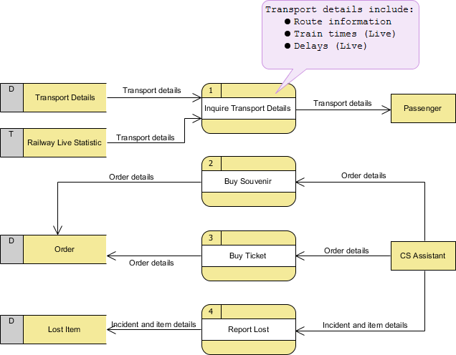

User Stories

User Type | User Story Number | User Story / Task | Acceptance criteria | Priority | Release
Student | USN 1 | As a user, I can add new contacts and update them anytime | Contacts should be added or updated quickly | High | Sprint 1
Developer | USN 2 | As a user, I can search contacts easily | System should display fast search results | High | Sprint 1
Manager | USN 3 | As a user, I can view and manage contact details of my team | Contacts should be fetched and updated quickly | High | Sprint 2

